**28 April Lab questions**

#1. WAP to replace all occurrences of a character in a given string with a new

character.

Code:

#include <stdio.h>

#include <string.h>

int main()

{

    int i_285,flag_285=0;

    char A_285[50],och_285,nch_285;

    printf("Please provide a short sentence\n");

    gets(A_285);

    printf("give old character\n");

    scanf("%c", &och_285);

    printf("give new character\n");

    scanf(" %c", &nch_285);

    printf("Your sentence before replacing is=\n");

    puts(A_285);

    for(i_285=0; A_285[i_285]!='\0' ;i_285++)

    {

        if(A_285[i_285]==och_285)

        {

            A_285[i_285]=nch_285;

            flag_285=1;

        }

    }

    if(flag_285==1)

    {

        printf("Your sentence after replacing is=\n");

        puts(A_285);

    }

    else

        printf("%c is not in your sentence\n",och_285);

}

Output:

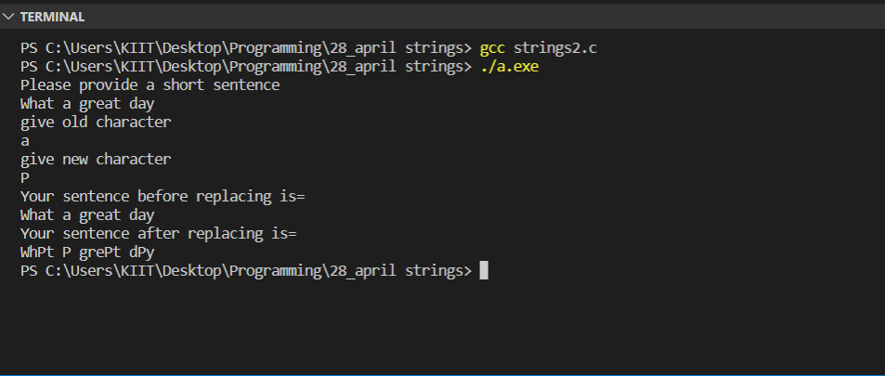

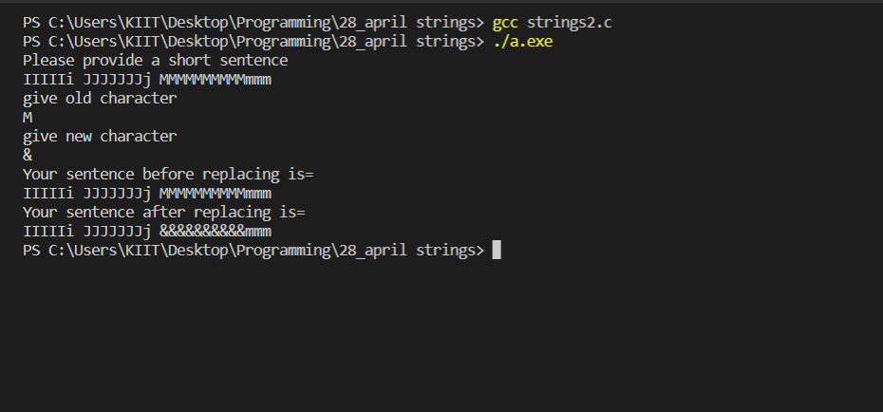

#2. Take input in a 2D string and print it.

Code:

#include <stdio.h>

#include <string.h>

int main()

{

    char A_285[3][10];

    int i_285,j_285;

    printf("Please give 3 words\n");

    for(i_285=0;i_285<3;i_285++)

    {

        scanf("%s",A_285[i_285]);

    }

    printf("Your words are as follows\n");

    for(i_285=0;i_285<3;i_285++)

    {

            printf(" %s ",A_285[i_285]);

            printf("\n");

    }

    return 0;

}

Output: